Design And Analysis of Algorithms
Project deliverable 1
22K-4818 Mustafa Masood
22K-5195 Laiba Fatima
22K-5198 Sabina

Q no 1:(a)

- Pseudo-Code:

FindMaxMin(array, left, right)
if left == right then
return (A[left], A[left])
else if right == left + 1 then
if A[left] > A[right] then
return (A[left], A[right])
else
return (A[right], A[left])
else
mid = ⌊(left + right) / 2⌋
(max1, min1) = FindMaxMin(A, left, mid)
(max2, min2) = FindMaxMin(A, mid + 1, right)

maxElement = max(max1, max2)
minElement = min(min1, min2)
return (max, min)

- Recurrence Relation:
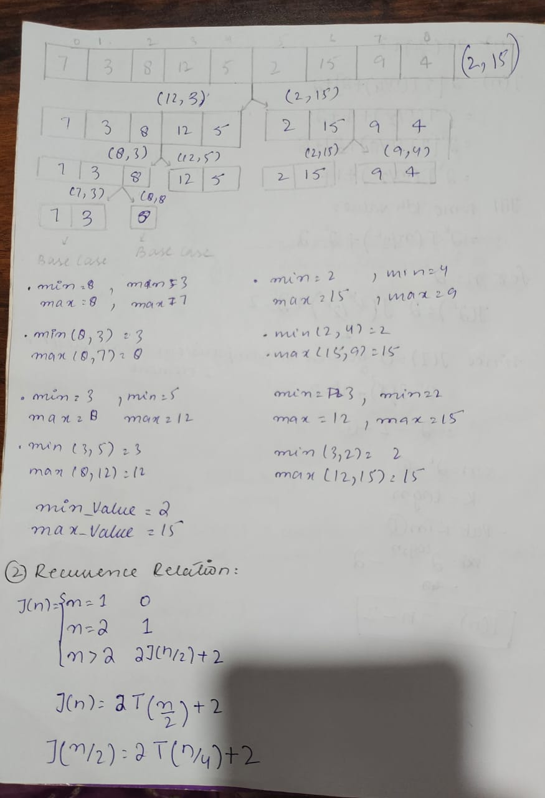
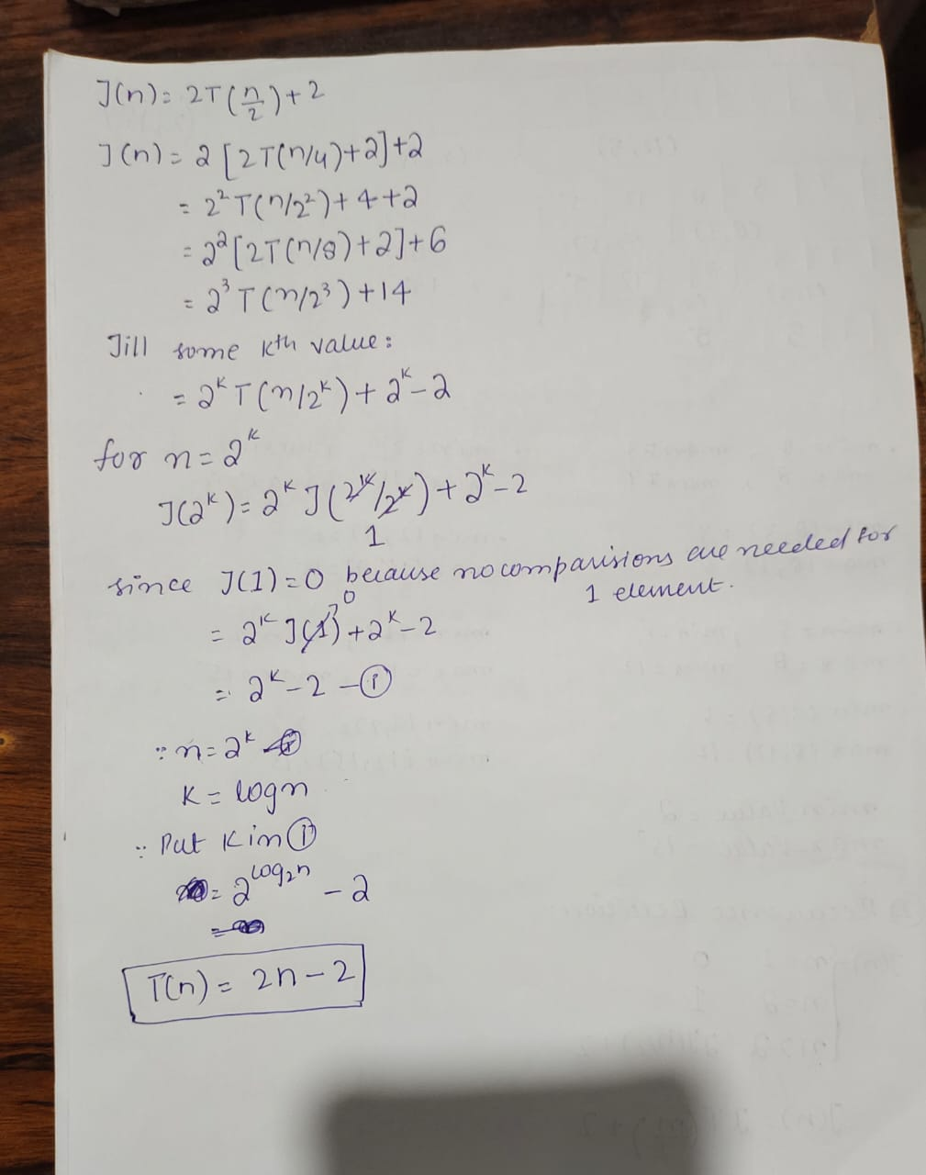

- Comparison:

The divide-and-conquer algorithm for finding both the largest and smallest elements in an array performs better in terms of key comparisons compared to the brute-force approach.

Brute-force algorithm: In this approach, we traverse the array and make (n-1) passes for finding the minimum and maximum element separately. This results in 2(n - 1) comparisons for each making a comparison of each element with the current element.

Divide-and-conquer algorithm: This approach recursively divides the array into smaller subarrays and compares pairs of elements which takes the same amount of operations as the brute force algorithm (2n-2).

Although both the brute-force and divide-and-conquer algorithms have the same time complexity, performing ( 2n - 2 ) comparisons, the divide-and-conquer approach introduces recursion overhead, as it involves multiple recursive calls, which add memory costs. Moreover, dividing the array and merging the results contribute further computational steps. In contrast, the brute-force algorithm performs a simple linear scan through the array. As a result, while both algorithms have the same complexity, the brute-force method is typically more efficient due to its straightforward execution.

Code:
public class Q1 {
public static int[] findMaxMin(int array[], int left, int right) {
int result[] = new int[2];

if (left == right) {
// 0th index contains maximum element
result[0] = array[left];
// 1st index contains minimum element
result[1] = array[left];
return result;
}
if (left + 1 == right) {
if (array[left] > array[right]) {
result[0] = array[left];
result[1] = array[right];
} else {
result[0] = array[right];
result[1] = array[left];
}
return result;
}

int mid = (left + right) / 2;

int[] leftResult = findMaxMin(array, left, mid);
int[] rightResult = findMaxMin(array, mid + 1, right);

result[0] = Math.max(leftResult[0], rightResult[0]);
result[1] = Math.min(leftResult[1], rightResult[1]);
return result;
}
public static void main(String[] args) {
int array[] = {7, 3, 8, 12, 5, 2, 15, 9, 4};
int result[] = findMaxMin(array, 0, array.length - 1);
System.out.println("Maximum element: " + result[0]);
System.out.println("Minimum element: " + result[1]);
}
}

Output:
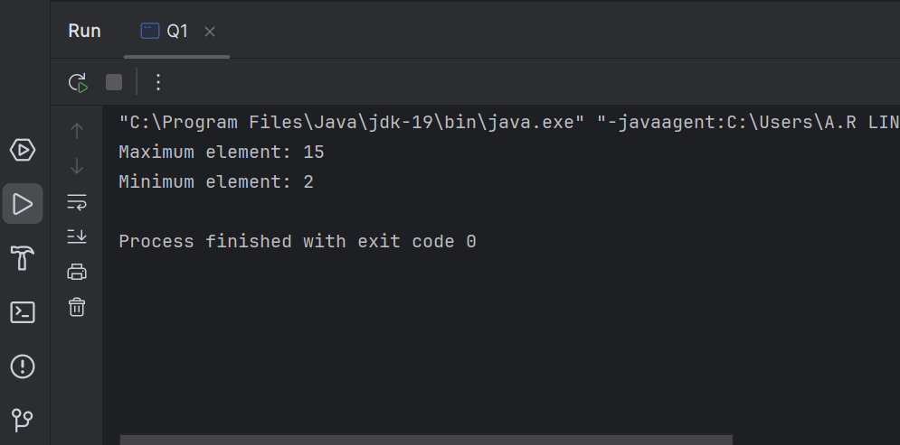

(b) 1- Pseudo-Code:

exponentiation(a, n){
If n = 0 then
return 1
else-If n = 1 then
return a
int result= Exponentiation(a, Math.floor(n/2))
If n %2==0 then
return result*result
else
return a * result * result
}

2 - Recurrence Relation:
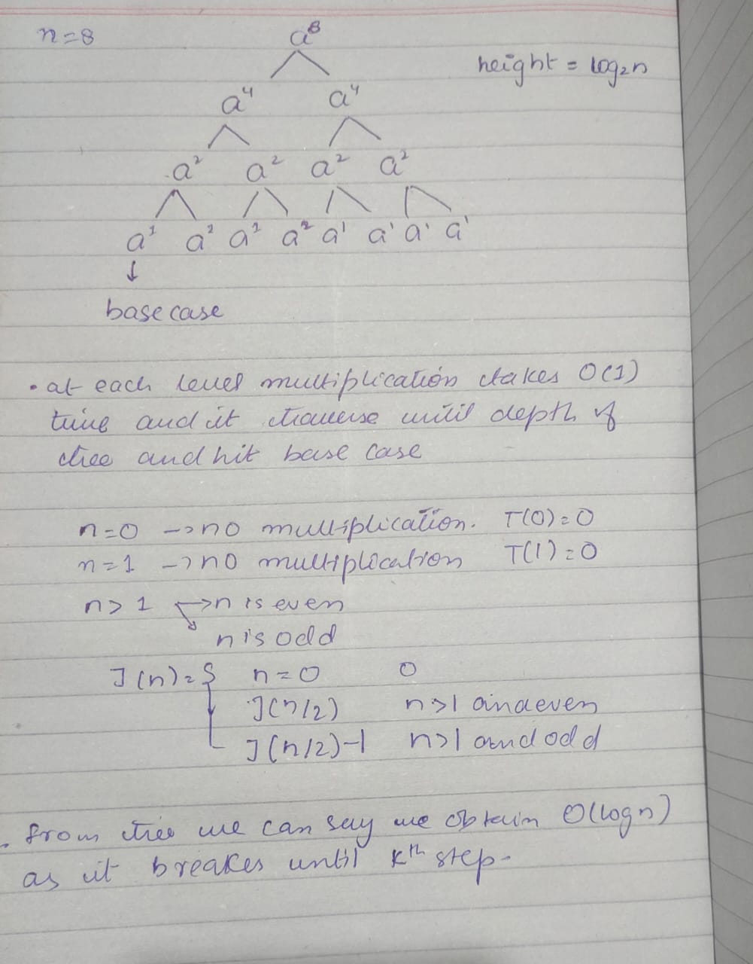

3 - Comparison:

In brute-force algorithm for computing a^n a will be multiplied by itself ( n−1) times, requiring n−1 multiplications. This gives the brute-force algorithm a time complexity of O(n).In comparison, the divide-and-conquer approach takes O(log⁡n) multiplication operations. So, for large values of n, the divide-and-conquer method is much more efficient than the brute-force approach.

Code:

public class Q2 {
public static int exponentiation(int a, int n) {
if (n == 0) {
return 1;
}
if (n == 1) {
return a;
}

int result = exponentiation(a, (int) Math.floor(n / 2));

if (n % 2 == 0) {
return result * result;
} else {
return a * result * result;
}
}

public static void main(String[] args) {
int a = 4;
int n = 10;
System.out.println(a+"^"+n+" = "+ exponentiation(a, n));
}
}

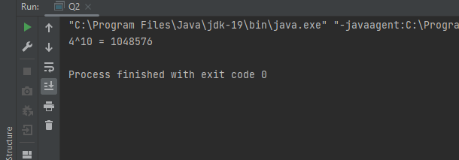
Output:

Q1: ( c )

public class Q3 {

public static int countInversions(int array[]) {
if (array == null || array.length == 0) {
return 0;
}
return mergeSort(array, 0, array.length - 1);
}

public static int mergeSort(int array[], int left, int right) {
if (left >= right) {
return 0;
}

int mid = left + (right - left) / 2;
int count = 0;

count =count+ mergeSort(array, left, mid);
count =count+ mergeSort(array, mid + 1, right);
count =count+ merge(array, left, mid, right);

return count;
}

private static int merge(int[] array, int left, int mid, int right) {
int[] leftArray = new int[mid - left + 1];
int[] rightArray = new int[right - mid];

for (int i = 0; i < leftArray.length; i++) {
leftArray[i] = array[left + i];
}
for (int i = 0; i < rightArray.length; i++) {
rightArray[i] = array[mid + 1 + i];
}

int i = 0, j = 0, k = left;
int count = 0;

while (i < leftArray.length && j < rightArray.length) {
if (leftArray[i] <= rightArray[j]) {
array[k++] = leftArray[i++];
} else {
array[k++] = rightArray[j++];
count += (mid + 1) - (left + i);
}
}

while (i < leftArray.length) {
array[k++] = leftArray[i++];
}

while (j < rightArray.length) {
array[k++] = rightArray[j++];
}

return count;
}

public static void main(String[] args) {
int[] array = { 1, 20, 6, 4, 5 };
System.out.println("Number of inversions: " + countInversions(array));
}
}

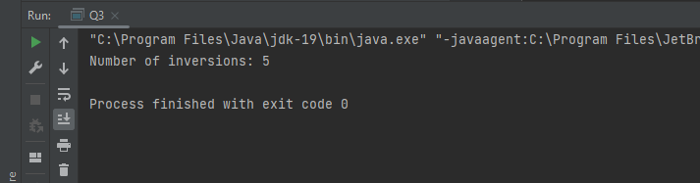
Output:

By using merge sort, we can reduce the number of comparisons. The merge sort itself operates in O(nlog⁡n) time, and by counting inversions during the merge step, we maintain the same time complexity. Thus, the algorithm counts inversions in O(nlog⁡n).

Q1: ( d )
The worst-case and best-case time complexities of the Quicksort algorithm are:
- Worst-case complexity: O(n²), which occurs when the partitioning is extremely unbalanced, such as when the pivot selected is always the smallest or largest element, leading to partitions of size 1 and n-1 repeatedly. An example of this case is when the input array is already sorted in increasing or decreasing order​.
- Best-case complexity: O(n log n), which happens when the partitioning is perfectly balanced, with each pivot splitting the array into two equal halves. In this case, the depth of recursion is log n, and each level requires linear time to partition the elements​
Q1: ( e )
- Algorithm
Divide:
Sort the array of n real numbers in non-decreasing order (this can be done in O(nlogn) using mergesort).
Split the array into two halves: left subarray and right subarray.
​
Conquer:
Recursively find the closest pair in the left half and the closest pair in the right half. Let the minimum distances in these halves be 𝑑𝐿 and 𝑑𝑅.

Combine:
Since the numbers are already sorted, the closest pair must either lie in one of the halves or span across the boundary between the two halves. The latter case would involve comparing the largest number in the left half with the smallest number in the right half. Let this distance be 𝑑cross.
The final closest pair distance is min(dL,dR,dcross).

Efficiency Class:
The algorithm first sorts the array in O(nlogn) time, and then recursively processes the two halves. The merge step (comparing the largest and smallest elements across the boundary) takes constant time.
Thus, the time complexity recurrence is: T(n)=2T(n/2)+O(1)
Solving this using the Master Theorem gives T(n)=O(nlogn).

Code:
public class ClosestPair {
public static double closestPair(double[] arr) {
mergeSort(arr, 0, arr.length - 1);
return findClosestPair(arr, 0, arr.length - 1);
}

private static double findClosestPair(double[] arr, int left, int right) {
if (left >= right) {
return Double.POSITIVE_INFINITY;
}

if (right - left == 1) {
return calculateDistance(arr[left], arr[right]);
}

int mid = (left + right) / 2;
double dL = findClosestPair(arr, left, mid);
double dR = findClosestPair(arr, mid + 1, right);
double dCross = calculateDistance(arr[mid], arr[mid + 1]);

return min(min(dL, dR), dCross);
}

private static double calculateDistance(double a, double b) {
return (a > b) ? (a - b) : (b - a);
}

private static double min(double a, double b) {
return (a < b) ? a : b;
}

private static void mergeSort(double[] arr, int left, int right) {
if (left < right) {
int mid = (left + right) / 2;
mergeSort(arr, left, mid);
mergeSort(arr, mid + 1, right);
merge(arr, left, mid, right);
}
}

private static void merge(double[] arr, int left, int mid, int right) {
int n1 = mid - left + 1;
int n2 = right - mid;

double[] L = new double[n1];
double[] R = new double[n2];

for (int i = 0; i < n1; i++) {
L[i] = arr[left + i];
}
for (int i = 0; i < n2; i++) {
R[i] = arr[mid + 1 + i];
}

int i = 0, j = 0, k = left;
while (i < n1 && j < n2) {
if (L[i] <= R[j]) {
arr[k] = L[i];
i++;
} else {
arr[k] = R[j];
j++;
}
k++;
}

while (i < n1) {
arr[k] = L[i];
i++;
k++;
}

while (j < n2) {
arr[k] = R[j];
j++;
k++;
}
}

public static void main(String[] args) {
double[] arr = {1.0, 3.5, 5.2, 7.8, 9.6, 2.3};
System.out.println("Closest Pair Distance: " + closestPair(arr));
}
}

Output:
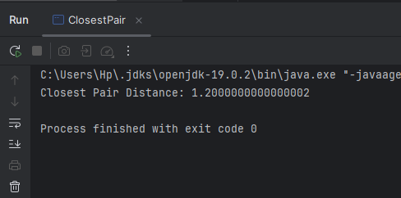
- Algorithm
This algorithm is efficient, with a time complexity of O(nlog⁡n), which is significantly better than the brute-force solution that takes O(n^2). This divide-and-conquer approach is optimal since sorting is necessary to find the closest pair in a systematic way. Therefore, it is considered a good algorithm for the one-dimensional closest-pair problem.

Q1: ( f ) Solved Exercise 1
public class UnimodalArrayPeak {
public static int findPeak(int[] A, int left, int right) {
if (left == right) {
return left;
}
int mid = (left + right) / 2;
if (A[mid] > A[mid - 1] && A[mid] > A[mid + 1]) {
return mid;
}
else if (A[mid] < A[mid + 1]) {
return findPeak(A, mid + 1, right);
}
else {
return findPeak(A, left, mid - 1);
}
}
public static void main(String[] args) {
int[] A = {1, 3, 8, 12, 9, 5, 2};
int peakIndex = findPeak(A, 0, A.length - 1);
System.out.println("Peak element is at index: " + peakIndex);
}
}
Output:
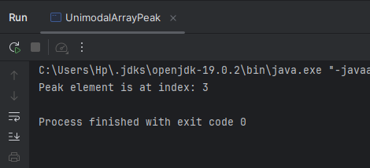
The algorithm recursively checks the middle element of the array, comparing it with its neighbors to decide whether to search in the left or right half.
Q1: ( g ) Solved Exercise 2
public class MaxProfitStock {
static class Result {
int buyDay;
int sellDay;
int profit;
Result(int buyDay, int sellDay, int profit) {
this.buyDay = buyDay;
this.sellDay = sellDay;
this.profit = profit;
}
}
public static Result findMaxProfit(int[] prices, int left, int right) {
if (left == right) {
return new Result(left, right, 0);
}
int mid = (left + right) / 2;
Result leftResult = findMaxProfit(prices, left, mid);
Result rightResult = findMaxProfit(prices, mid + 1, right);
int minPriceInLeft = Integer.MAX_VALUE;
int minPriceDay = left;
for (int i = left; i <= mid; i++) {
if (prices[i] < minPriceInLeft) {
minPriceInLeft = prices[i];
minPriceDay = i;
}
}
int maxPriceInRight = Integer.MIN_VALUE;
int maxPriceDay = mid + 1;
for (int i = mid + 1; i <= right; i++) {
if (prices[i] > maxPriceInRight) {
maxPriceInRight = prices[i];
maxPriceDay = i;
}
}
int crossProfit = maxPriceInRight - minPriceInLeft;
if (leftResult.profit >= rightResult.profit && leftResult.profit >= crossProfit) {
return leftResult;
} else if (rightResult.profit >= leftResult.profit && rightResult.profit >= crossProfit) {
return rightResult;
} else {
return new Result(minPriceDay, maxPriceDay, crossProfit);
}
}
public static void main(String[] args) {
int[] prices = {9, 1, 5, 8, 12, 3, 7};
Result result = findMaxProfit(prices, 0, prices.length - 1);
System.out.println("Buy on day: " + (result.buyDay + 1) + ", Sell on day: " + (result.sellDay + 1) + ", Profit: $" + result.profit);
}
}
Output:
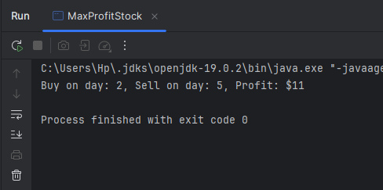
Q1: ( h )
1.Median of Two Databases
Input: Two sorted arrays of numbers A and B, each containing n numbers.
Output: The median of the combined set of numbers.
Pseudocode:
1.If both arrays have only one element, return the average of the two elements.
2.Find the middle element of both arrays, Amid and Bmid.
3.If Amid is less than or equal to Bmid then :Discard the first half of A and the second half of B, and recursively find the median of the remaining parts.
4.If Amid is greater than Bmid then : Discard the second half of A and the first half of B, and recursively find the median of the remaining parts.
5.Keep repeating the process until the median is found.

Code:
public class MedianOfTwoArrays {
public static double findMedian(int[] A, int[] B) {
if (A.length > B.length) {
return findMedian(B, A);
}
int x = A.length;
int y = B.length;
int low = 0, high = x;

while (low <= high) {
int partitionX = (low + high) / 2;
int partitionY = (x + y + 1) / 2 - partitionX;

int maxX = (partitionX == 0) ? Integer.MIN_VALUE : A[partitionX - 1];
int maxY = (partitionY == 0) ? Integer.MIN_VALUE : B[partitionY - 1];

int minX = (partitionX == x) ? Integer.MAX_VALUE : A[partitionX];
int minY = (partitionY == y) ? Integer.MAX_VALUE : B[partitionY];

if (maxX <= minY && maxY <= minX) {
if ((x + y) % 2 == 0) {
return ((double) Math.max(maxX, maxY) + Math.min(minX, minY)) / 2;
} else {
return (double) Math.max(maxX, maxY);
}
} else if (maxX > minY) {
high = partitionX - 1;
} else {
low = partitionX + 1;
}
}
throw new IllegalArgumentException();
}

public static void main(String[] args) {
int[] A = {1, 3, 8};
int[] B = {7, 9, 10, 11};
System.out.println(findMedian(A, B));
}
}

Output:
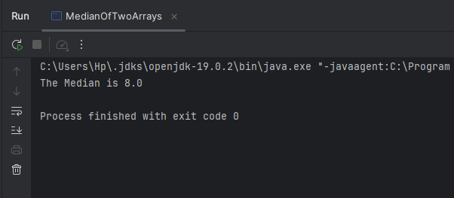

2. Significant Inversions
Input: An array of numbers.
Output: The number of significant inversions, where ai >2×aj for i<j.
Pseudocode:
1.If the array contains only one element, there are no inversions, so return 0.
2.Split the array into two halves.
3.Recursively count the significant inversions in the left half.
4.Recursively count the significant inversions in the right half.
5.During the merging process:
5.1.Compare elements from both halves.
5.2.For each element in the left half, check how many elements in the right half are less than half of it.
5.3.Add this count to the total number of significant inversions.
6.Merge the two halves back together in sorted order.
7.Return the total number of significant inversions (left, right, and cross inversions).
Code:
public class SignificantInversions {

public static int countSignificantInversions(int[] arr) {
if (arr == null || arr.length < 2) {
return 0;
}
return mergeSortAndCount(arr, 0, arr.length - 1);
}

private static int mergeSortAndCount(int[] arr, int left, int right) {
if (left >= right) {
return 0;
}

int mid = left + (right - left) / 2;
int count = mergeSortAndCount(arr, left, mid) + mergeSortAndCount(arr, mid + 1, right);
count += mergeAndCount(arr, left, mid, right);

return count;
}

private static int mergeAndCount(int[] arr, int left, int mid, int right) {
int count = 0;
int n1 = mid - left + 1;
int n2 = right - mid;

int[] leftArr = new int[n1];
int[] rightArr = new int[n2];

for (int i = 0; i < n1; i++) {
leftArr[i] = arr[left + i];
}
for (int i = 0; i < n2; i++) {
rightArr[i] = arr[mid + 1 + i];
}

int j = 0;
for (int i = 0; i < n1; i++) {
while (j < n2 && leftArr[i] > 2 * rightArr[j]) {
j++;
}
count += j;
}

int i = 0, k = left;
j = 0;

while (i < n1 && j < n2) {
if (leftArr[i] <= rightArr[j]) {
arr[k++] = leftArr[i++];
} else {
arr[k++] = rightArr[j++];
}
}

while (i < n1) {
arr[k++] = leftArr[i++];
}
while (j < n2) {
arr[k++] = rightArr[j++];
}

return count;
}

public static void main(String[] args) {
int[] arr = {1, 3, 2, 3, 1};
System.out.println("Number of significant inversions: " + countSignificantInversions(arr));
}
}

Output:
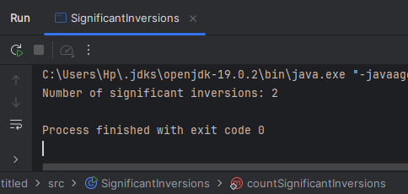

3. Fraud Detection with Bank Cards
Input: A set of n bank cards, where some cards may belong to the same account.
Output: The account that has more than n/2 cards, or none if there isn't one.
Pseudocode:
1.If there is only one card, return that card as the majority.
2.Split the set of cards into two equal halves.
3.Recursively find the majority card in the left half.
4.Recursively find the majority card in the right half.
5.Compare the majority card from the left half with the one from the right half:
5.1.If both cards are from the same account (using the equivalence tester), return that card.
6.If the left and right candidates are different:
6.1.Count how many times the left candidate appears in the whole set.
6.2.Count how many times the right candidate appears in the whole set.
6.3.Return the candidate that appears more than n/2 times (if any).
7.If no card appears more than n/2 times, return "No majority account."

Code:
public class FraudDetection {

public static String findMajorityAccount(String cards[], int left, int right) {
if (left == right) { // if only 1 card
return cards[left];
}
if (right == left + 1) {
if (cards[left].equals(cards[right])) {
return cards[left];
} else {
return "No majority";
}
}
int mid = (left + right) / 2;
String leftMajority = findMajorityAccount(cards, left, mid);
String rightMajority = findMajorityAccount(cards, mid + 1, right);
if (leftMajority.equals(rightMajority)) {
return leftMajority;
}
int leftCount = countOccurrences(cards, leftMajority, left, right);
int rightCount = countOccurrences(cards, rightMajority, left, right);

int n = right - left + 1;
if (leftCount > n / 2) {
return leftMajority;
} else if (rightCount > n / 2) {
return rightMajority;
} else {
return "No majority account available";
}
}

public static int countOccurrences(String cards[], String candidate, int left, int right) {
int count = 0;
for (int i = left; i <= right; i++) {
if (cards[i].equals(candidate)) {
count++;
}
}
return count;
}
public static void main(String[] args) {
String cards[] = {"A1", "A2", "A1", "A1", "A3", "A1", "A1", "A2", "A1", "A1"};
String majority = findMajorityAccount(cards, 0, cards.length - 1);
System.out.println("Majority account : " + majority);
}
}

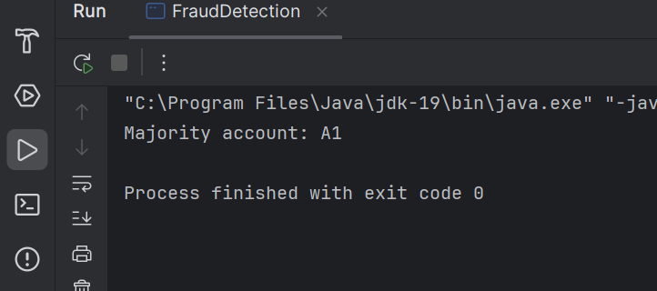
Output:

